1. Go to <http://www.oracle.com/technetwork/articles/javase/jdk-netbeans-jsp-142931.html>
2. Click on “Accept License Agreement”.
3. There are two different files for Windows. Which one should you choose?

* **If you don’t know, choose “jdk-8u101-nb-8_1-windows-i586.exe” (see below)**
* *If you are absolutely sure you run a 64-bit version of Windows, choose Windows x64.*

*Tip:* [*How do I know if my PC runs a 32-bit or 64-bit version of Windows?*](https://support.microsoft.com/en-us/kb/827218)

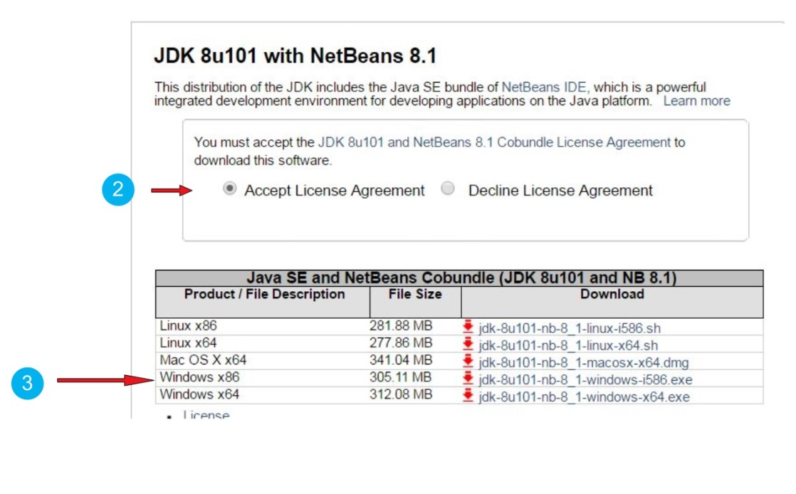

1. Find the file you downloaded on your computer and click on it to install.

***Note*** *that you might need administrator rights to install software on your PC!*

***Now that we have NetBeans installed, let’s add the Codename One plugin.***

1. Open NetBeans. In the menu, select Tools -> Plugins.  
   In the windows opening, select “Available plugins”. Search for “Codename One” (plugins can be listed alphabetically by clicking on the column “name”, that makes it easier to find).  
   Select the Codename One plugin by ticking the box on the left. Click on “Install” and follow instructions.
2. Restart NetBeans to finish the installation.

***Congratulations, you are ready to create your first mobile app!***

Level of difficulty:   
Estimated time: 5 mn + download.

[**www.codapps.io**](http://www.codapps.io)by Clement Levallois **@codapps_io** [**www.coursera.org/learn/codapps**](http://www.coursera.org/learn/codapps)



**Module 1: Installation of useful tools for the course**

*How to install NetBeans and the Codename One plugin on a PC*